READ AND DRAW

A black cat. | 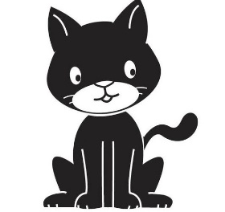
An orange train

A purple pencil.

A white ball.

A happy boy

A green bird.

Classe 3^

