READ AND TICK TRUE OR FALSE.

Hello, I am Tom, I am a boy. I live in London.
I am 11 years old. I am tall and quite slim.
I have got black hair and brown eyes.
I have got a mother, a father, a brother and a baby sister.
My favourite colour is . I like 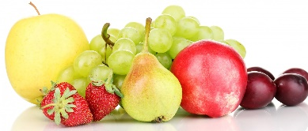.

- Tom is a girl. TRUE FALSE
- Tom is English. TRUE FALSE
- Tom is twelve. TRUE FALSE
- Tom is short. TRUE FALSE
- Tom’s family is large. TRUE FALSE
- Tom’s favourite colour is green. TRUE FALSE
- Tom does not like fruit. TRUE FALSE

WRITE ABOUT YOU

Hello, I am …….…………. I live ……………………………........................

………………………………………………………………………………

………………………………………………………………………..…………

…………………………………………………………………………………

